Федеральное государственное образовательное бюджетное

учреждение высшего образования

**«Финансовый университет при Правительстве Российской Федерации»**

**(Финансовый университет)**

Колледж информатики и программирования

**ОТЧЕТ О ВЫПОЛНЕНИИ ЗАДАНИЯ № 7**

**Тема: “События C#”**

Студент: Добагов Д.З.

Группа: 3ПКС-420

Преподаватель: Сибирев И.В.

Дата:29.11.2022

Москва, 2022

**Цель Работы:** разработать калькулятор на языке C#.

**Решение:**

Пример вывода консоли:

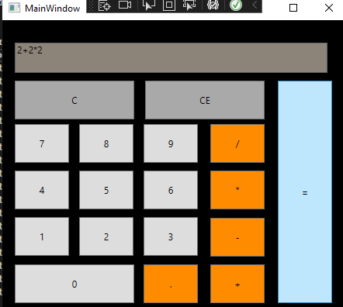

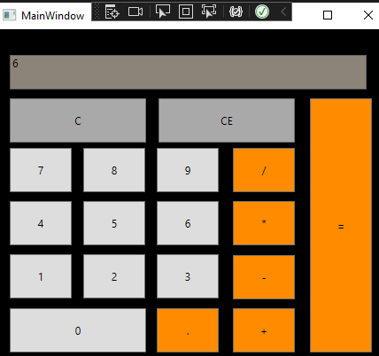

Код:

using System;

using System.Collections.Generic;

using System.Linq;

using System.Text;

using System.Threading.Tasks;

using System.Windows;

using System.Windows.Controls;

using System.Windows.Data;

using System.Windows.Documents;

using System.Windows.Input;

using System.Windows.Media;

using System.Windows.Media.Imaging;

using System.Windows.Navigation;

using System.Windows.Shapes;

namespace WpfApp1

{

/// <summary>

/// Логика взаимодействия для MainWindow.xaml

/// </summary>

public partial class MainWindow : Window

{

public MainWindow()

{

InitializeComponent();

}

private void CE(object sender, RoutedEventArgs e)

{

TextBox.Clear();

}

private void N1_Click(object sender, RoutedEventArgs e)

{

TextBox.Text += 1;

}

private void N2_Click(object sender, RoutedEventArgs e)

{

TextBox.Text += 2;

}

private void N3_Click(object sender, RoutedEventArgs e)

{

TextBox.Text += 3;

}

private void N4_Click(object sender, RoutedEventArgs e)

{

TextBox.Text += 4;

}

private void N5_Click(object sender, RoutedEventArgs e)

{

TextBox.Text += 5;

}

private void N6_Click(object sender, RoutedEventArgs e)

{

TextBox.Text += 6;

}

private void N7_Click(object sender, RoutedEventArgs e)

{

TextBox.Text += 7;

}

private void N8_Click(object sender, RoutedEventArgs e)

{

TextBox.Text += 8;

}

private void N9_Click(object sender, RoutedEventArgs e)

{

TextBox.Text += 9;

}

private void N0_Click(object sender, RoutedEventArgs e)

{

TextBox.Text += 0;

}

private void Button_Click(object sender, RoutedEventArgs e)

{

TextBox.Text += "√";

}

private void Button_Click_1(object sender, RoutedEventArgs e)

{

TextBox.Text += "/";

}

private void Button_Click_2(object sender, RoutedEventArgs e)

{

TextBox.Text += "*";

}

private void Button_Click_3(object sender, RoutedEventArgs e)

{

TextBox.Text += "-";

}

private void Button_Click_4(object sender, RoutedEventArgs e)

{

TextBox.Text += "+";

}

private void ravno(object sender, RoutedEventArgs e)

{

TextBox.Text = Convert.ToString(Eval(TextBox.Text)).Replace(",", ".");

}

static Double Eval(String expression)

{

System.Data.DataTable table = new System.Data.DataTable();

return Convert.ToDouble(table.Compute(expression, String.Empty));

}

private void Button_Click_5(object sender, RoutedEventArgs e)

{

TextBox.Text += ".";

}

private void Button_Click_6(object sender, RoutedEventArgs e)

{

TextBox.Text = TextBox.Text.Remove(TextBox.Text.Length - 1);

}

}

}

Xaml:

<Window x:Class="WpfApp1.MainWindow"

xmlns="http://schemas.microsoft.com/winfx/2006/xaml/presentation"

xmlns:x="http://schemas.microsoft.com/winfx/2006/xaml"

xmlns:d="http://schemas.microsoft.com/expression/blend/2008"

xmlns:mc="http://schemas.openxmlformats.org/markup-compatibility/2006"

xmlns:local="clr-namespace:WpfApp1"

mc:Ignorable="d"

Title="MainWindow" Background="Black" Height="420" Width="460">

<Grid Margin="10,20,10,-6">

<Grid.RowDefinitions>

<RowDefinition Height="420*"/>

<RowDefinition Height="11*"/>

</Grid.RowDefinitions>

<TextBox Name="TextBox" Background="AntiqueWhite" HorizontalAlignment="Left" IsEnabled="False" Height="39" Margin="06,9,0,0" TextWrapping="Wrap" VerticalAlignment="Top" Width="403" RenderTransformOrigin="0.496,0.433"/>

<Button Content="C" Background="DarkGray" HorizontalAlignment="Left" Margin="6,58,0,0" VerticalAlignment="Top" Width="154" Height="50" Click="CE" />

<Button Name ="N1" Content="1" HorizontalAlignment="Left" Margin="6,234,0,0" VerticalAlignment="Top" Width="70" Height="50" Click="N1_Click"/>

<Button Name ="N2" Content="2" HorizontalAlignment="Left" Margin="89,234,0,0" VerticalAlignment="Top" Width="70" Height="50" Click="N2_Click"/>

<Button Name ="N3" Content="3" HorizontalAlignment="Left" Margin="172,234,0,0" VerticalAlignment="Top" Width="70" Height="50" Click="N3_Click"/>

<Button Name ="N4" Content="4" HorizontalAlignment="Left" Margin="6,174,0,0" VerticalAlignment="Top" Width="70" Height="50" Click="N4_Click"/>

<Button Name ="N5" Content="5" HorizontalAlignment="Left" Margin="89,174,0,0" VerticalAlignment="Top" Width="70" Height="50" Click="N5_Click"/>

<Button Name ="N6" Content="6" HorizontalAlignment="Left" Margin="172,174,0,0" VerticalAlignment="Top" Width="70" Height="50" Click="N6_Click"/>

<Button Name ="N7" Content="7" HorizontalAlignment="Left" Margin="6,114,0,0" VerticalAlignment="Top" Width="70" Height="50" Click="N7_Click"/>

<Button Name ="N8" Content="8" HorizontalAlignment="Left" Margin="89,114,0,0" VerticalAlignment="Top" Width="70" Height="50" Click="N8_Click"/>

<Button Name ="N9" Content="9" HorizontalAlignment="Left" Margin="172,114,0,0" VerticalAlignment="Top" Width="70" Height="50" Click="N9_Click"/>

<Button Name ="N0" Content="0" HorizontalAlignment="Left" Margin="6,295,0,0" VerticalAlignment="Top" Width="154" Height="50" Click="N0_Click"/>

<Button Content="." Background="DarkOrange" HorizontalAlignment="Left" Margin="172,295,0,0" VerticalAlignment="Top" Width="70" Height="50" Click="Button_Click_5"/>

<Button Content="/" Background="DarkOrange" HorizontalAlignment="Left" Margin="258,114,0,0" VerticalAlignment="Top" Width="70" Height="50" Click="Button_Click_1"/>

<Button Content="*" Background="DarkOrange" HorizontalAlignment="Left" Margin="258,174,0,0" VerticalAlignment="Top" Width="70" Height="50" Click="Button_Click_2"/>

<Button Content="-" Background="DarkOrange" HorizontalAlignment="Left" Margin="258,235,0,0" VerticalAlignment="Top" Width="70" Height="50" Click="Button_Click_3"/>

<Button Content="+" Background="DarkOrange" HorizontalAlignment="Left" Margin="258,295,0,0" VerticalAlignment="Top" Width="70" Height="50" Click="Button_Click_4"/>

<Button Content="=" Background="DarkOrange" HorizontalAlignment="Left" Margin="345,58,0,0" VerticalAlignment="Top" Width="70" Height="287" Click="ravno"/>

<Button Content="CE" Background="DarkGray" HorizontalAlignment="Left" Margin="174,58,0,0" VerticalAlignment="Top" Width="154" Height="50" Click="Button_Click_6"/>

</Grid>

</Window>

**Вывод:** Я разработал калькулятор на языке С#.